**Build a Workflow from Scratch with SAP Cloud Platform Workflow Management**DEV163

Exercise 2.1 | Business Rules  
Archana Shukla / SAP

Table of ContentS

AUTHOR, ACTIVATE AND DEPLOY BUSINESS RULES 3

OVERVIEW 3

CREATE PROJECT 4

CREATE DATA OBJECTS 7

CONFIGURE VALUE HELP IN DATA OBJECT 12

CREATE RULE SERVICE 15

CREATE DECISION TABLE RULE 19

IMPORT DECISION TABLE FROM MICROSOFT EXCEL 27

CREATE RULESET 33

ACTIVATE RULES PROJECT 36

DEPLOY RULE SERVICE 38

CREATE VERSION 39

Test business Rule 41

OVERVIEW 41

DISCOVER BUSINESS RULES API 42

CONFIGURE TEST ENVIRONMENT 43

INVOKE BUSINESS RULES 46

Summary 48

# 

# AUTHOR, ACTIVATE AND DEPLOY BUSINESS RULES

## OVERVIEW

Estimated time: 45 minutes

The exercise is based on authoring and managing rules for capital expenditure, using SAP Cloud Platform Business Rules. The rule determines the approvers based on investment details.

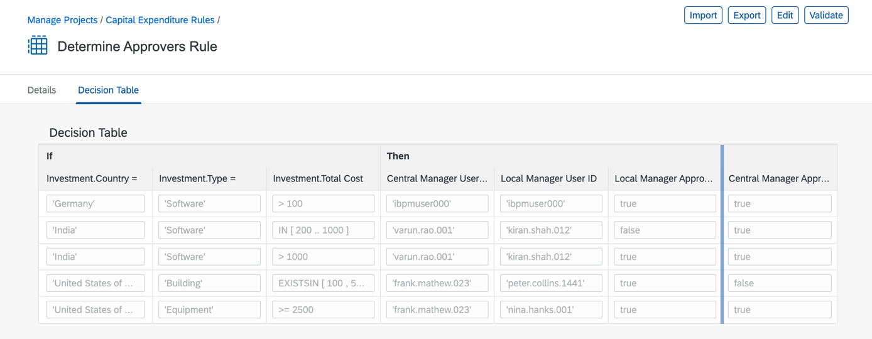

In this exercise, you will learn about different enterprise rule models and how to author them using Manage Rules Application. You will create, configure and activate these business rules models, and learn how to deploy the rule service to cloud for consumption.

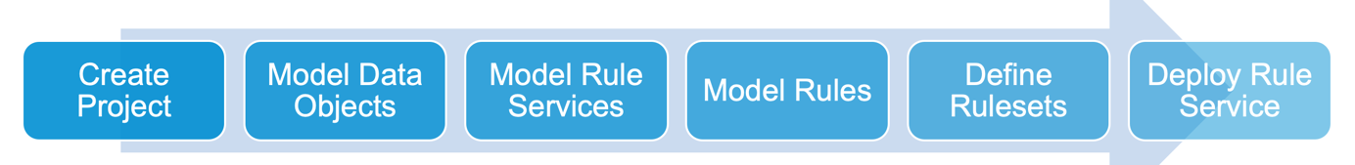

Exercise Description:

In this exercise you will do the following:

* *Create and Configure Project*
* *Create Data Objects*
* *Configure Data Object with Value Help*
* *Create Ruleservice*
* *Create Decision Table*
* *Create Ruleset*
* *Activate Projects and other Models*
* *Deploy Ruleservice in Cloud Platform*
* *Create Rule Version*
* *Test Business Rules*

## CREATE PROJECT

| Explanation | Screenshot |
| --- | --- |
| 1. Open Workflow Management Launchpad and click to open **Manage Rule Projects.**     * Login with trial username and passwords |  |
| 1. Click to create a new business rules project. |  |
| 1. Configure Project Name 2. Click on the **Name** text box. |  |
|
| 1. Enter **CAPEX_00** in the **Name** box. |  |
| 1. Enter **Capital Expenditure Rules** in the **Label** box. |  |
| 1. Enter **Capital Expenditure Rules** in the **Label** box. |  |
| 1. Enter **Business rules to determine approvers for new investments in capital expenditure process** in **Description** box. |  |
| 1. Click to select **2.0** as the **Expression Language**. |  |
| 1. Click . |  |
| Your business rules project is created with the needed configurations. |  |

## CREATE DATA OBJECTS

| Explanation | Screenshot |
| --- | --- |
| 1. Click . |  |
| 1. Create **Data Object.** 2. Click . |  |
|
| 1. Enter **Investment** in the **Name** and the **Label** box. |  |
| 1. Enter **Details of the investment** in the **Description** box. |  |
| 1. Click . |  |
| 1. Click . |  |
| 1. Enter **Type** in the **Name** and **Label** box. 2. Enter **Type of investment** in the **Description** box. |  |
| 1. Click . |  |
| 1. Repeat the steps to create more data object attributes with following details:      | **Name** | **Label** | **Description** | **Type** | | --- | --- | --- | --- | | Currency | Currency | Currency | String | | Country | Country | Country | String | | TotalCost | Total Cost | Total cost of investment | Number | |  |
| 1. Click . |  |
| 1. Click . |  |
| 1. Click .   Note: Ensure that you are in **Data Objects** tab. |  |
| 1. Enter **Approvers** in **Name** box. 2. Enter **Approvers** in **Label** box**.** 3. Enter **Detail of investment approvers** in **Description** box. |  |
| 1. Click . |  |
| 1. Repeat the steps to create Approvers data objectattributes with following details:     Attributes:   | **Name** | **Label** | **Description** | **Type** | | --- | --- | --- | --- | | cm_userid | Central Manager User ID | User ID of central manager | String | | lm_userid | Local Manager User ID | User ID of local manager | String | | lm_required | Local Manager Approval Required | Is approval required from local manager? | Boolean | | cm_required | Central Manager Approval Required | Is approval required from central manager? | Boolean | |  |
| 1. Click . |  |
| 1. Click . |  |
| You have created and configured data objects in business rules project. **Investment** data object will be used as *Input* and **Approver** data object will be used as *Output* in the rule service. These data object & their attributes will be used while modelling rule expressions. |  |

## CONFIGURE VALUE HELP IN DATA OBJECT

| Explanation | Screenshot |
| --- | --- |
| 1. Click to open **Investment** data object. |  |
| 1. Click to add attributes to the data object. |  |
|
| 1. Click to open **Type** attribute. |  |
| 1. Click . |  |
| 1. Click . |  |
| 1. Click . |  |
| 1. Click **Value List**. |  |
| Note: there are two kinds of value help (a) Static and (b) Dynamic. Dynamic *value he*lp can be created with Service **URL Mapping** and **Static** c*an be c*reated with **Value List** type**.** In dynamic value you can connect any backend system and make a service call. In this exercise, you will create static value help where you will manually create value-description pair.   1. Click to on the **Value List** row**.** |  |
| 1. Click to add values to the value list. |  |
| 1. Click and enter **Software** in **Value** and **Description** box**.** |  |
| 1. Repeat the steps above to add few more values:  | **Value** | **Description** | | --- | --- | | Machinery | Machinery | | Building | Building | | Equipment | Equipment | | Service | Service | |  |
| 1. Click . |  |
| 1. Click . |  |
| 1. Click . |  |
| 1. Click . |  |
| 1. Click . |  |

## CREATE RULE SERVICE

| Explanation | Screenshot |
| --- | --- |
| 1. Click . |  |
| 1. Create **Rule Service****.** 2. Click . |  |
|
| 1. Click to enter **DetermineApprovers** in **Name** box. 2. Click to enter **Determine Approvers** in **Label** box. |  |
| 1. Click to enter **Rule service to determine approvers for new investment** in **Description** box. |  |
| 1. Click . |  |
| 1. Click . |  |
| 1. Click to select **Investment.** |  |
| 1. Click to select **Input**. |  |
| 1. Click . |  |
| 1. Click to select **Approvers**. |  |
| 1. Click **Result**. |  |
| 1. Click . |  |
| 1. Click . |  |
| You have created and configured Rule Service which will be finally deployed once we have configured all the rule entity models. |  |

## CREATE DECISION TABLE RULE

| Explanation | Screenshot |
| --- | --- |
| 1. Click . |  |
| 1. Create Rule 2. Click . |  |
|
| 1. Click to enter **DetermineApproversRule** in **Name** box. |  |
| 1. Click . |  |
| 1. Click and enter **Determine Approvers Rule** in **Label** box. |  |
| 1. Click to enter **Rules to determine approvers for the new investments based on type, country and total cost of the investment** in **Description** box . |  |
| 1. Click . |  |
| 1. Click . |  |
| Note: As you start typing in the **Condition Expression** box, you will get in-place context help with the list of Vocabulary, Operators and Functions.   1. Click and enter **in** the condition expression box. 2. From the in-place context sensitive help options, select **Investment >> Country** |  |
| 1. Click . |  |
| 1. Click . |  |
| 1. In **Fixed Operator** drop down, click **=** **is** **equal** operator**.** |  |
| 1. Click . |  |
| 1. Repeat the steps above to add few more condition expressions as following:        | **Condition Expression** | **Fixed Operator** | | --- | --- | | Investment.Type | = | | Investment.Total Cost |  | |  |
| 1. Click  to select **Result** data object**.** |  |
| 1. Select or Double-click on **Approvers**. |  |
| Note: You will notice **Access** column as the result properties. When you set access as hidden, the respective column will not be seen during rule authoring in decision table.   1. Click . |  |
| 1. Click on the input field of **Investment.Country** column and enter **'Germany'**.     After you have finished typing, press **Enter** key to confirm or click outside the input field. |  |
| Note: In this expression, you will choose the value from the value help defined for this attribute.   1. Please press **Ctrl+ Space** or press any key**.** |  |
| 1. Expand **Fixed Value** and clickto select value help. |  |
| 1. Click to select **Software** from the value help. |  |
| 1. Click **Enter** to confirm or click outside the input field. |  |
| 1. Click to enter **> 100** 2. Press **Enter** toconfirm. |  |
| 1. Similarly, enter the following expression values for the respective result column:  | **Result Column** | **Expression Value** | | --- | --- | | Central Manager User ID | your trial user number | | Local Manager User ID | Your trial user number | | Local Manager Approval Required | true | | Central Manager Approval Required | true | |  |
| 23. Click . |  |
| You have created a decision table-based rule with condition and result columns. You have added a row to the decision table and used in-place context sensitive help to add expressions to the cell values. Now, in next chapter you will use Microsoft Excel to import the data in the decision table. |  |

## IMPORT DECISION TABLE FROM MICROSOFT EXCEL

| Explanation | Screenshot |
| --- | --- |
| 1. Download the **DetermineApproversRule** excel in the same folder in GitHub. 2. Open the excel and update **Project Name,** **Project ID** and **Rule ID** in the available excel sheet as shown in steps below. 3. Update project name with your rules project name like CAPEX_00. |  |
| Now, to update the Project ID and Rule ID you have to go back to the Manage Rule Projects.   1. Navigate back to projects. 2. Click . |  |
|
| 1. Click . |  |
| 1. Click . |  |
| 1. Click . |  |
| 1. Select and press **Ctrl+C** or **Command+C** to copy. |  |
| 1. Paste the copied **Project ID**.   Note: ensure that there are no leading or lagging space while you do the copy & paste. |  |
| 1. Click to open project. |  |
| 1. Click . |  |
| 1. Click . |  |
| 1. Click . |  |
| 1. Click . |  |
| 1. Select and press **Ctrl+C** or **Command+C** to copy. |  |
| 1. Paste the Rule ID   Note: ensure that there are no leading or lagging spaces while you do the copy paste   1. Also, change the *cm_userid* and *lm_userid* ofthe first row (line number 6) to your trial username. |  |
| 1. Click to open the rule. |  |
| 1. Click . |  |
| 1. Click and select the excel sheet updated in steps above. |  |
| 1. Click . |  |
| You will have the rows imported in your decision table. |  |
| 1. Click . |  |
| 1. Click . |  |
| 1. Click . |  |

## CREATE RULESET

| Explanation | Screenshot |
| --- | --- |
| 1. Click **Rulesets.** |  | |
| 1. Create Ruleset 2. Click . |  | |
|
| 1. Click to enter **DetermineApproversRuleset** in **Name** box. |  | |
| 1. Click to enter **Determine Approvers Ruleset** in **Label** box. |  | |
| 1. Click to enter **Ruleset that contain rules needed for determining approvers for the new investments** in **Description** box. |  | |
| 1. Click to select **DetermineApprovers** as **Rule Service**. |  | |
| 1. Click . |  | |
| 1. Click . |  | |
| 1. Click . |  | |
| 1. Click to select . |  | |
| 1. Click . |  | |
| 1. Click . |  | |
| You have created the ruleset, associated it with rule service and added the rule. Ruleset is a collection of rules of similar output. |  | |

## ACTIVATE RULES PROJECT

| Explanation | Screenshot |
| --- | --- |
| Before you deploy the rule service, all the rule entity models have to be in activated state. In this chapter, you will go through all the models to ensure that they are activated.   1. Click . |  |
| 1. Click . |  |
|
| 1. Click . |  |
| 1. Click . |  |
| 1. Check if all the data objects are in **Active** state. |  |
| 1. Check if all the rule services are in **Active** state. |  |
| 1. Check if all rulesets are in **Active** state. |  |
| 1. Check if all rules are in **Active** state. |  |

## DEPLOY RULE SERVICE

| Explanation | Screenshot |
| --- | --- |
| 1. Click . |  |
| 1. Click . |  |
| 1. Click **SAP Cloud Platform** todeploy the rule service. |  |
| 1. After the ruleset is deployed successfully, you will see the message. Now, the rule service can be consumed via the REST APIs |  |

## CREATE VERSION

| Explanation | | Screenshot |
| --- | --- | --- |
| 1. Click on **Details** tab 2. Click **Release Version** to create a new version of the rules project. | |  |
| 1. **Enter** the following in the Release Version pup-up:   Version: 1.0.0  Revision: Trial  Description: Basic capex approval rules for new investment requests.   1. Click **Release** | |  |
| 1. To view the version created, **navigate back** to main page by clicking on Manage Projects link on top-left corner of the screen 2. Click the **checkbox** of the business rules project for which you created the version. 3. Click **History**. | |  |
|
|
| You will see all the versions of the rule Project created here.   1. Click to navigate into version 1.0.0 |  | | |
| 1. Click **Rule Services** tab. 2. Click **Deploy.** |  | | |
|
| 1. Click **SAP Cloud Platform** todeploy the rule service. |  | | |
| 1. After the rule service is deployed successfully, you will see the message.   Now, the rule service can be consumed via the REST APIs |  | | |

# Test business Rule

## OVERVIEW

Estimated time: 15 minutes

In the following exercise you will learn the basics of testing business rules invocation from APIs available in SAP API Business Hub.

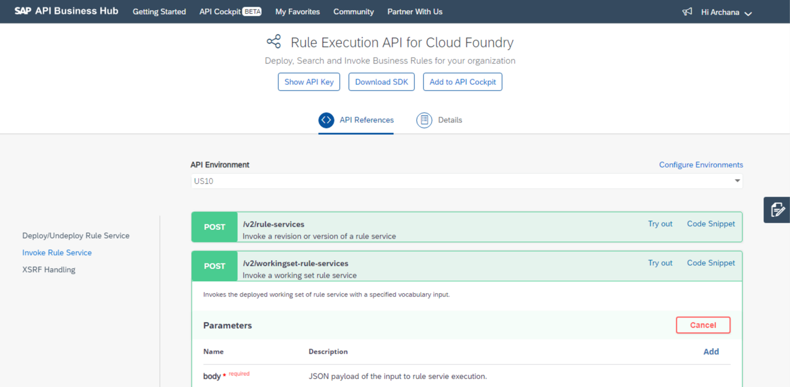

Exercise Description

In this exercise you will do the following:

* Discover Business Rules API in SAP API Business Hub
* Configure Cloud Foundry Test Environment
* Invoke Business Rules

## DISCOVER BUSINESS RULES API

| Explanation | Screenshot |
| --- | --- |
| 1. Open **API Business Hub** using this URL: <https://api.sap.com> 2. Click . 3. using your S or P user ID |  |
| 1. Search Business Rules API 2. In **Search** box, enter **business rule** and press **Enter key** to search. |  |
|
| 1. Click  API Package. |  |
| 1. Enter **execution** in the  box. |  |
| Note: Business Rules have two set of APIs: Authoring and Execution. You will also notice two set of versions v1 and v2. Version v1 is currently deprecated and will soon be unsupported.   1. Click  to search the execution APIs. |  |
| 1. Click on **Rule Execution API for Cloud Foundry** version v2 APIs. |  |

## CONFIGURE TEST ENVIRONMENT

| Explanation | Screenshot |
| --- | --- |
| 1. Click . |  |
| Fetch the information from Business Rules service instance key to configure the API Hub environment. To do so,   1. Login to your cloud platform trial account and navigate into your sub-account. 2. From left panel, click **Service Instances**. 3. From among the available instances, click on **wm_businessrules** instance to view service keys. 4. From available service keys, click  on any service key and select **View**. |  |
| 1. Copy the    * rule_runtime_url,    * clientid,    * clientsecret,    * url (this is token url)   These will be used to configure the testing environment in API Business Hub. |  |
| 1. Set configuration properties   Enter the respective details in the configuration properties as copied from the business rules service key in previous step:   * **Display Name**: Trial * **runtimeurl:** <as copied above> * **Client Id:** <as copied above> * **Secret:** <as copied above>   Press **Tab** to move to next property. |  |
|
|
| 1. Enter the following as token url and other standard properties:   **tokenurl**: <as copied above>  Note: please remove https:// from the token url and copy the rest.  For Example: If the URL is <https://db73ff38trial.authentication.eu10.hana.ondemand.com>  Then token URL will be: db73ff38trial.authentication.eu10.hana.ondemand.com   1. Click  **for Apply this environment to all APIs**. 2. Click  for **Save this environment for future sessions**. |  |
| 1. Click . |  |
| 1. Click . |  |
| There are two kinds of runtime APIs.   * The first one is for versioned invocation which means if you have deployed any version of the rule service and want to invoke it. * The second one is for the working set invocation which means that you do not have any version but have deployed the working set directly.  1. From the left options, click . |  |

## INVOKE BUSINESS RULES

| Explanation | Screenshot |
| --- | --- |
| 1. Click  of **/v2/working-set-rule-services** API. |  |
| 1. Execute Working Set API 2. Click . |  |
|
| 1. Press **Tab** until you reach the body section. 2. In the **body** section**, Copy & Paste** this text:   {   "RuleServiceId": "ba2229ca79874fe381ced8a4ee6dad21",         "Vocabulary": [             {                 "Investment": {                     "Currency": "EUR",                     "Country": "Germany",                     "Type": "Software",                     "TotalCost": 10000                 }             }         ]     }  Replace the **RuleServiceId** with rule service id of your rules project. |  |
| 1. Click **Execute**. |  |
| You will see the response after the successful rule execution.  Try and change the country to “India” in the input body, and you will see a different response. |  |

# Summary

You have completed the exercise!

You are now able to:

* Create & Activate Project, Data Object, Ruleservice, Ruleset and Rules.
* Configure Value Help in Data Object.
* Use Microsoft Excel Import/Export functionality in Decision Table.
* Deploy Ruleservice in SAP Cloud Platform.
* Discover Business Rules API in SAP API Business Hub.
* Configure Test Environment for Cloud Foundry.
* Execute Business Rules Execution API.

# 